Week 4
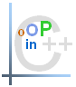

Exercise 1 (20 marks)
Many programs written with inheritance could be solved with composition instead, and vice versa. Discuss the relative merits of these approaches in the context of the Point, Circle, Cylinder class hierarchy. Rewrite the program of Fig. 9.4 the updated version in your lecture notes (and the supporting classes) to use composition rather than inheritance. After you do this, reassess the relative merits of the two approaches both for the Point, Circle, Cylinder problem and for object-oriented programs in general
All about how you design.
Eg circle can inherit from Point
But Line needs two points.
One point inherit and one point compose?
No.
Better to compose P1,P2 and make two points.
//point.h
#pragma once
#include <iostream>

using std::ostream;

class Point {
public:
Point(int = 0, int = 0); // default constructor
void setPoint(int, int); // set coordinates
int getX() const { return x; } // get x coordinate
int getY() const { return y; } // get y coordinate
void print() const;
protected: // accessible by derived classes
int x, y; // x and y coordinates of the Point
};
//point.cpp
#include <iostream>
#include "point.h"

using namespace std;

// Constructor for class Point
Point::Point(int a, int b) { setPoint(a, b); }

// Set x and y coordinates of Point
void Point::setPoint(int a, int b)
{
x = a;
y = b;
}

void Point::print() const
{
cout << '[' << x << ", " << y << ']' << endl;
}

//circle.h
#pragma once
#include <iostream>
#include "point.h"

class Circle {
public:
// default constructor
Circle(double r = 0.0, int x = 0, int y = 0);

void setRadius(double); // set radius
double getRadius() const; // return radius
double area() const; // calculate area
void print() const;

//as no inheritance
int setX() const { return x; }
int setY() const { return y; }
//circle.cpp
#include <iostream>
using std::cout;
using std::endl;
using std::ios;

#include <iomanip>
using std::setiosflags;
using std::setprecision;

#include "circle.h"

// Constructor for Circle calls constructor for Point
// with a member initializer then initializes radius.
Circle::Circle(double r, int a, int b)
{
setCircle(r, a, b);
}

// Set radius of Circle
void Circle::setRadius(double r)
{
radius = (r >= 0 ? r : 0);
}

// Get radius of Circle
double Circle::getRadius() const { return radius; }

// Calculate area of Circle
double Circle::area() const
{
return 3.14159 * radius * radius;
}

void Circle::print() const
{
cout << '[' << x << ", " << y << ']' << endl;
cout << "; Radius = " << radius;
}

//set circle
void Circle::setCircle(int r, int a, int b)
{
x = a;
y = b;
radius = r;
}
void setCircle(int, int, int); //set the circle

private:
double radius;
int x, y;
};

//cylinder.h
#pragma once
#include "circle.h"

class Cylinder {
public :
//default constructor
Cylinder(double h = 0.0, double r = 0.0,
int x = 0, int y = 0);
void setHeight(double);
double getHeight();
double area() const;
double volume() const;
void print() const;

//as no inheritance
int setX() const { return x; }
int setY() const { return y; }
void setRadius(double); // set radius
double getRadius() const; // return radius
void setCylinder(int, int, int, int); //set the cylinder

private :
double height, radius;
int x, y;
};
//cylinder.cpp
#include "cylinder.h"
#include <iostream>
using std::cout;
using std::endl;

Cylinder::Cylinder(double h, double r, int x, int y)
{
setHeight(h);
}

void Cylinder::setHeight(double h)
{
height = h > 0 ? h : 0;
}

double Cylinder::getHeight() { return height; }

double Cylinder::area() const
{
// surface area of Cylinder
return 2 * 3.14159 * radius * radius + 2 * 3.14159 * getRadius() * height;
}

double Cylinder::volume() const
{
return 3.14159 * radius * radius * height;
}

void Cylinder::print() const
{
cout << '[' << x << ", " << y << ']' << endl;
cout << "; Radius = " << radius;
cout << "\n; Height = " << height;
}

//set cylinder
void Cylinder::setCylinder(int h, int r, int a, int b)
{
x = a;
y = b;
radius = r;
height = h;
}

// Set radius of Circle
void Cylinder::setRadius(double r)
{
radius = (r >= 0 ? r : 0);
}

// Get radius of Circle
double Cylinder::getRadius() const { return radius; }

//main.cpp
#include <iostream>
using namespace std;

#include "point.h"
#include "circle.h"
#include "cylinder.h"

int main()
{
int a, b, c,d;
cout << "Enter x, y, radius and height : ";
cin >> a >> b >> c >> d;
Point point(a,b); // create a Point
Circle circle(c,a,b); // create a Circle
Cylinder cylinder(d,c,a,b); // create a Cylinder

point.print(); // static binding
cout << "\n";

circle.print(); // static binding
cout << "\n; Area : "<<circle.area();
cout << "\n\n";

cylinder.print(); // static binding
cout << "\n; Area : " << cylinder.area();
cout << "\n; Volume : " << cylinder.volume();
cout << "\n\n";

}

Exercise 2 (20 marks)
Rewrite the Point, Circle, Cylinder program of exercise 1 using inheritance.
//point.h
#pragma once
#include <iostream>

using std::ostream;

class Point {
public:
Point(int = 0, int = 0); // default constructor
void setPoint(int, int); // set coordinates
int getX() const { return x; } // get x coordinate
int getY() const { return y; } // get y coordinate
void print() const;
protected: // accessible by derived classes
int x, y; // x and y coordinates of the Point
};
//point.cpp
#include <iostream>
#include "point.h"

using namespace std;

// Constructor for class Point
Point::Point(int a, int b) { setPoint(a, b); }

// Set x and y coordinates of Point
void Point::setPoint(int a, int b)
{
x = a;
y = b;
}

void Point::print() const
{
cout << '[' << x << ", " << y << ']' << endl;
}

//circle.h
#pragma once
#include <iostream>
#include "point.h"

class Circle : public Point { // Circle inherits from Point
public:
// default constructor
Circle(double r = 0.0, int x = 0, int y = 0);

void setRadius(double); // set radius
double getRadius() const; // return radius
double area() const; // calculate area
void print() const;

//if no inheritance
/*
void setX(int a){x=a;}
void setY(int b){y=b;}
*/
protected:
double radius;
};
//circle.cpp
#include <iostream>
using std::cout;
using std::endl;
using std::ios;

#include <iomanip>
using std::setiosflags;
using std::setprecision;

#include "circle.h"

// Constructor for Circle calls constructor for Point
// with a member initializer then initializes radius.
Circle::Circle(double r, int a, int b)
: Point(a, b) // call base-class constructor
{
setRadius(r);
}

// Set radius of Circle
void Circle::setRadius(double r)
{
radius = (r >= 0 ? r : 0);
}

// Get radius of Circle
double Circle::getRadius() const { return radius; }

// Calculate area of Circle
double Circle::area() const
{
return 3.14159 * radius * radius;
}

void Circle::print() const
{
Point::print();
cout << "; Radius = " << radius;
}

//cylinder.h
#pragma once
#include "circle.h"

class Cylinder : public Circle{
public :
//default constructor
Cylinder(double h = 0.0, double r = 0.0,
int x = 0, int y = 0);
void setHeight(double);
double getHeight();
double area() const;
double volume() const;
void print() const;

private :
double height;
};
//cylinder.cpp
#include "cylinder.h"
#include <iostream>
using std::cout;

Cylinder::Cylinder(double h, double r, int x, int y)
: Circle(r, x, y) // call base-class constructor
{
setHeight(h);
}

void Cylinder::setHeight(double h)
{
height = h > 0 ? h : 0;
}

double Cylinder::getHeight() { return height; }

double Cylinder::area() const
{
// surface area of Cylinder
return 2 * Circle::area() + 2 * 3.14159 * getRadius() * height;
}

double Cylinder::volume() const
{
return Circle::area() * height;
}

void Cylinder::print() const
{
Circle::print();
cout << "\n; Height = " << height;
}

//main.cpp
#include <iostream>
using namespace std;

#include "point.h"
#include "circle.h"
#include "cylinder.h"

int main()
{
int a, b, c,d;
cout << "Enter x, y, radius and height : ";
cin >> a >> b >> c >> d;
Point point(a,b); // create a Point
Circle circle(c,a,b); // create a Circle
Cylinder cylinder(d,c,a,b); // create a Cylinder

point.print(); // static binding
cout << "\n";

circle.print(); // static binding
cout << "\n; Area : "<<circle.area();
cout << "\n\n";

cylinder.print(); // static binding
cout << "\n; Area : " << cylinder.area();
cout << "\n; Volume : " << cylinder.volume();
cout << "\n\n";

}
Exercise 3 (10 marks)
Expand the program in exercise 2 as a Point, line, square, Cube using inheritance.

Exercise 4 (50 marks)

The project tutor of the Applied Computing Department has decided to design a system to help tracking the student’s project deliverables during the final year project life cycle. He has designed the system in object classes through a sequence of steps. Your job here is to follow these steps and implement the system according to the given specifications of the classes.

Section 1: First Step (10 marks)

In this section you need to implement the two classes shown in figure 1. Test the classes by creating an instant for each.
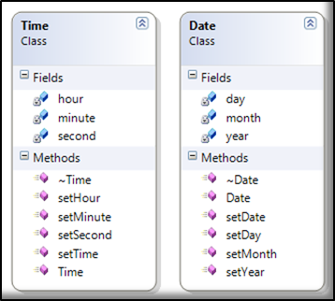

Figure 1: Shows the classes Time and Date

Section 2: Second Step (20 marks)

In this section you need to add three new classes as shown in figure 2. The composition of the new classes is explained as follows:
- Project: this class takes both classes “Date” and “Supervisor” as a data members.
- Student: this class takes both classes “Date” and “Project” as a data member.
Make sure that you have the proper program code for the class constructors for the classes. Test the new classes by creating an instant for each class.

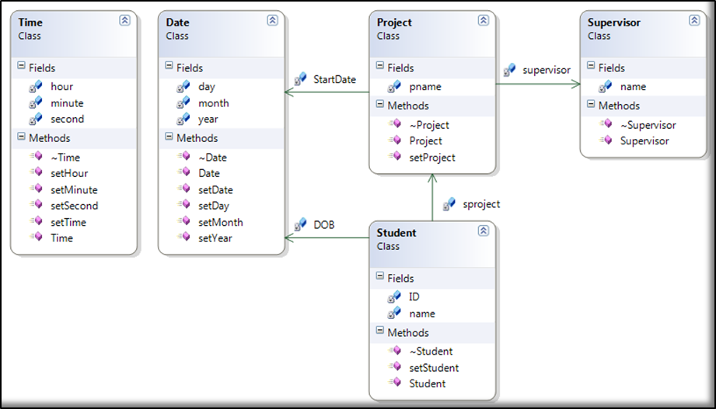

Figure 2: Shows three classes added with their associations

Section 3: Third Step (20 marks)

In this section you need to implement the Deliverable class. This class takes “Time”, “Date”, and “Student” classes as its data members. Here you must make sure that all constructors will be called in a proper way. Test the “Deliverable” class by creating an instant in your main function.

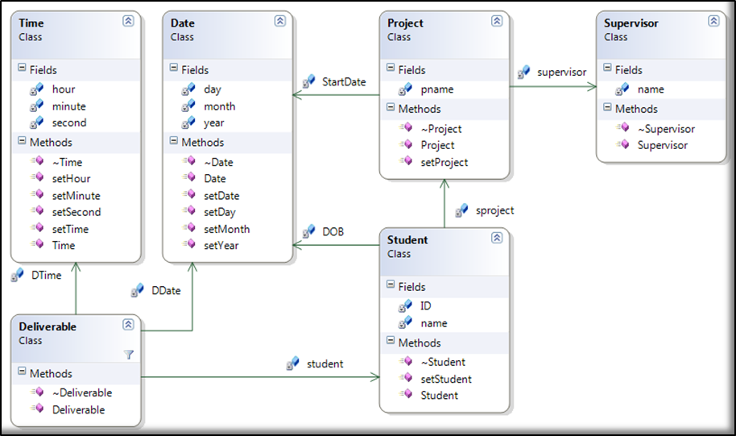

Figure 3: show the Deliverable class added

